

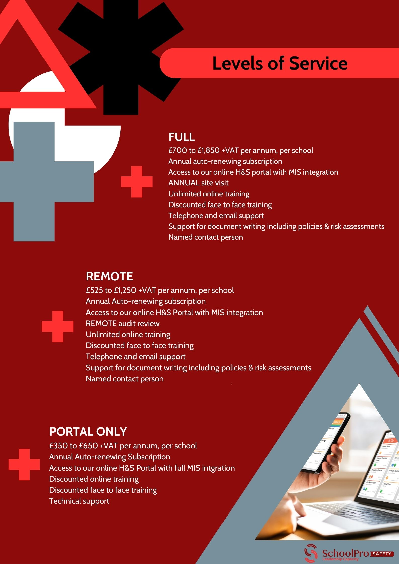

School Name:
Project Title |  | Project Number
School Lead
Brief project description
The form below is just a template, you should add and change as much as you want
Text in red is just suggestions and will depend on your school’s individual policy. The form is currently 7 pages long it will work best if you delete most of this text and get it down to 4 or even less pages.

Contractor Selections / Procurement
Contractor Selected |  |  |  |  |  | Number of Quotes Obtained
Financial Checks |  |  | Yes | No | notes
Insurance documents provided
 | Indemnity |  | Yes | No | notes
 | Public Liability (£10 million) |  | Yes | No | notes
 | Workers Compensation Insurance |  | Yes | No | notes
Certification from industry body |  |  | Yes | No | Which certification
Risk Assessments provided |  |  | Yes | No | notes
Previous clients / recommendations |  |  | Yes | No | notes
DBS certificates for all workers |  |  | Yes | No | notes

Pre-Commencement
Method statement or specific risk assessments for this project | Does the statement address the following |  |  | Notes
Site Security | N/A | Y | N
Visitors and Deliveries | N/A | Y | N
Working hours | N/A | Y | N
Accident reporting | N/A | Y | N
Waste management | N/A | Y | N
Noise Control | N/A | Y | N
Dust Control | N/A | Y | N
Vehicles on site and pedestrian safety | N/A | Y | N
First Aid | N/A | Y | N
Hot works | N/A | Y | N
Signage | N/A | Y | N
Fire Safety | N/A | Y | N
Dangerous Goods and Substances | N/A | Y | N
Live Electrical works | N/A | Y | N
Electrical Disruption | N/A | Y | N
Disruption to other services (drinking water etc) | N/A | Y | N
Environmental consideration | N/A | Y | N
Welfare of workers and their access to toilets | N/A | Y | N
Work at height and risk of falling objects | N/A | Y | N

During work
School contact  name |  | Contractor contact name
School contact phone number |  | Contractor phone number
Sign in / Sign out procedure | Select one and edit, or write something that works best for your setting  1. Digital Check-In System  Install a digital sign-in kiosk at the main entrance specifically for contractors. Contractors sign in using a tablet or QR code that logs their name, company, time in, and time out. Alerts can be sent to relevant school staff whenever a contractor arrives or departs.  2. Physical Sign-In Log at Reception  Place a physical sign-in book at the school's reception desk. Contractors must provide their name, company, purpose of visit, and expected duration. The reception staff can review and validate contractor IDs to ensure only authorized individuals are on-site.  3. Badge System with Escort Requirement  Upon arrival, contractors sign in at reception and receive a temporary badge. Contractors are escorted by a school representative to the work area and checked upon departure, ensuring they sign out and return their badge before leaving.
Supervision | Select one and edit, or write something that works best for your setting  1. Liaison Oversight  You will be supervised by a designated school liaison, who will check in with you regularly. Follow their instructions, keep them informed of your progress, and address any questions or concerns directly with them.  2. Compliance with Safety Audits and Spot Checks  Expect regular safety audits and spot checks throughout your workday. Ensure you are fully compliant with PPE requirements, stay within designated work areas, and follow all safety protocols at all times.  3. Shadowing in Sensitive Areas  A trained staff member may be assigned to shadow you, particularly if you are working in high-risk or sensitive areas. Follow their guidance carefully, stay within designated boundaries, and immediately address any feedback or instructions they provide.  4. Participate in Daily Briefings and Debriefs  Attend daily briefings at the start of each day to review risks and safety procedures, and participate in end-of-day debriefs to confirm your progress and discuss any issues. These meetings are mandatory and crucial for safety and compliance.  5. Adhere to Video Monitoring Policies  In designated work areas, video monitoring may be in place for supervision. Always work within the boundaries specified and adhere to safety protocols. Monitoring is in place to support safety and to maintain a secure environment for everyone.
Areas of work | What areas are the contractors allowed / not allowed to access?  What areas are the students allowed / not allowed to access?  What areas are the staff allowed / not allowed to access?  How will this be managed / enforced?  What are the welfare arrangements for the contractors?
Waste | Select one and edit, or write something that works best for your setting  1. Segregate Waste by Type (Contractor's Responsibility)  You are responsible for separating waste into designated categories (e.g., general, recyclable, hazardous) as you work. Use the clearly labeled bins provided on-site to avoid cross-contamination and ensure compliance with environmental policies. The school will provide labeled bins but expects proper sorting to be managed by your team.  2. Adhere to Scheduled Waste Removal Times (Contractor's Responsibility)  You are responsible for removing and transporting your waste at the scheduled times provided by the school to minimize disruption. Only transport waste at these designated times, using the agreed-upon routes to avoid interfering with school activities.  3. Handle Hazardous Waste with Extra Care (Contractor's Responsibility)  Any hazardous materials, such as chemicals or sharp objects, are your responsibility and must be disposed of according to strict safety protocols. Use sealed, labeled containers and arrange for immediate removal by a certified waste disposal service organized by your team.  4. Maintain a Clean and Safe Work Area (Contractor's Responsibility)  It is your responsibility to keep your work area tidy by regularly clearing debris and placing waste in assigned containers. A clean site reduces hazards and helps ensure safety for both contractors and school occupants. The school will check periodically to ensure these standards are met.  5. Dispose of Waste Off-Site in Compliance with Regulations (Contractor's Responsibility)  You are responsible for transporting all collected waste to an approved off-site disposal facility, ensuring compliance with local regulations. Keep all disposal documentation and provide copies to the school to demonstrate regulatory compliance.
Behaviour | Feel free to use any or all of these. Alternatively write some more appropriate to your setting and delete the ones you don’t think suitable.  Respectful Conduct: Maintain a professional demeanor at all times, using appropriate language and courteous behavior when interacting with students, staff, and other contractors.  Identification and Badging: Always wear your contractor ID badge in a visible location and follow the school’s sign-in and sign-out procedures each day.  Awareness of Surroundings: Be mindful of the presence of students and staff; avoid disruptive or loud behavior, particularly near classrooms and high-traffic areas.  Restricted Area Compliance: Remain within designated work areas and avoid entering restricted zones, especially those near students, without prior authorization.  Safety Gear and PPE: Wear all required personal protective equipment (PPE) at all times and adhere strictly to site safety regulations.  No Smoking or Vaping: Refrain from smoking or vaping on school grounds, as these are strictly prohibited.  No Use of Profanity: Use appropriate language at all times, avoiding profanity or inappropriate conversations, especially within earshot of students.  Adherence to Scheduled Work Hours: Stick to the pre-arranged work hours and minimize disruptions during peak school times, such as breaks and class changeovers.  Maintain Cleanliness: Keep your work area tidy, dispose of waste properly, and clean up daily to ensure a safe and orderly environment.  No Photography: Do not take photographs or videos of the school premises, students, or staff unless explicitly authorized by the school administration.  Mobile Device Use: Limit mobile phone use to essential work-related communications only, particularly in areas visible to students.  Report Incidents Immediately: Report any safety incidents, accidents, or near misses to the designated school contact without delay.  Respect School’s Emergency Procedures: Familiarize yourself with and follow the school’s emergency procedures, including evacuation routes and assembly points.  Child-Safe Behavior: Avoid direct interaction with students and ensure a safe distance is maintained at all times, respecting safeguarding protocols.
Hazards to workers | These are just examples of risks your school might pose to the contractors. This section should make the specific risks very clear. Including the location of the risk and information on managing it.  Asbestos: Older school buildings may contain asbestos in insulation, ceiling tiles, and flooring, posing a risk during renovations or maintenance work.  Electrical Hazards: Live wires, overloaded circuits, and faulty equipment can present risks of electric shock or fire.  Slips, Trips, and Falls: Wet floors, loose carpeting, uneven surfaces, and cluttered hallways can lead to accidents.  Chemical Exposure: Cleaning supplies, art materials, and science lab chemicals may pose risks of exposure or allergic reactions if not handled properly.  Workplace Violence: There is potential for confrontations with aggressive individuals, including students or visitors, especially in high-stress situations.  Child Safety Risks: Working near children can present risks if workers are not vigilant about equipment, tools, and materials that could be hazardous to students.
Emergency Procedures | Select one and edit or write something that works best for your setting  - Evacuate to the Designated Assembly Point  In the event of an emergency, immediately evacuate to the designated contractor assembly point, located [specify location]. Ensure all workers are accounted for and stay at the assembly point until further instructions are given.  2. Follow School Emergency Signals and Alarms  When the school’s emergency alarm sounds, stop all work immediately and follow the school’s emergency procedures. Listen to announcements and follow any directions given by school staff or the emergency response team.  3. Coordinate with School’s Emergency Team  Upon arrival on-site, review the school’s emergency procedures and evacuation routes provided by the school’s emergency team. During an emergency, ensure your lead contractor coordinates closely with the school’s emergency contact.  4. Provide First Aid if Necessary  In the event of an emergency, ensure that a qualified first aider within your team is available to provide first aid if needed. Make sure a well-stocked first aid kit is accessible on-site.  5. Report All Incidents to the School Immediately  If an emergency incident or near miss occurs, notify the designated school contact immediately. Document the incident promptly and be prepared to participate in any follow-up actions as required by the school.
Permit to Work | Where your setting requires the contractors to use a permit to work system this should be made clear. Areas where this is common are suggested below.  Asbestos Abatement  Electrical Work  Demolition Work  Hot Work (e.g., welding, cutting)  Roofing Work

Sign off
 |  | Contractor Signature
We have provided the school with all necessary documentation
We have read and will abided by the rules and instructions in this document
School Signature (suggest head of setting or other senior leader) |  |  | Date

Supervision audit
Date / time of observation | Notes and agreed actions | School Signature | Contractor  Signature

